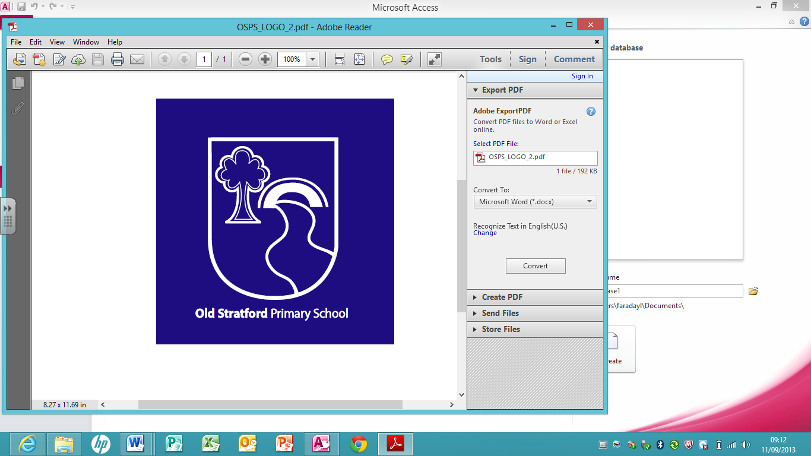

Old Stratford Primary School

Willow Grove, Old Stratford, Milton Keynes, MK19 6AZ

Tel: 01908 267700

Email: head@oldstratford.northants-ecl.gov.uk

Dear All,

As you know we have been following a process over the past year with the objective of Old Stratford joining the Grand Union Academy Trust led by Phil Webster. When I updated you last time we had completed a consultation process with parents and staff and were about to do three things:

1. Make a formal application to become an academy
2. Conduct due diligence on Grand Union particularly from a financial, governance and teaching perspective and of course for the trust to do the same on Old Stratford.
3. Consult with the local education authority (LEA) to ensure they were informed and also to provide any input to the process from their perspective.

I am pleased to confirm that due diligence has concluded and that we had found no concerns, on the contrary the process has demonstrated more strongly the benefits for us of joining the trust. We also consulted with the LEA financial lead, Kathryn Walker, who Karen and I invited to school to take her through our due diligence approach. Her conclusion was that we had conducted an extremely thorough process, and based on the evidence provided by Grand Union could see no concerns in us joining the trust and a number of potential benefits.

In response to our formal application the Regional Schools Commissioner has given approval to our academy process. Therefore we have moved onto the final stage, and appointed legal advisers to conduct the transfer process with Northampton County Council. I also wrote to all staff on Friday to start formal consultation on the transfer to the Trust.

This has been an intensive process over the past few months and therefore Phil Webster, Karen Sarbutts and I would like to invite you to a presentation on 19th June at 7.00 pm. At this meeting we will take you through the process we have followed, and the benefits we believe joining the trust will bring to our school, continuing the progress we have made in the past two years recognised in our recent OFSTED report. The Governing Board will make a final decision on joining the trust on 27th June.

I hope as many of you as possible can join us on the 19th, but if you cannot and would like more information, or have any questions, please contact either Karen Sarbutts or Phil Webster at the school or email me at andrew.brodie@faccenda.co.uk.

Kind regards

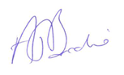

Andrew Brodie

Chair of Governors