Friday 22nd May 2020

Dear Parents and Guardians.
I am a parent Governor at Old Stratford Primary School and report to the Governors Committee on the Health and Safety of the School.
Like many parents, to hear the Governments announcement which meant my son would be returning to Year 6 obviously gave me some concerns. This period of Lockdown has been one of adjustment , community, concern and compassion. It is understandable that such a period also brings anxiety as we venture out again.
As part of my role with the Governors, I have been into the school to undertake and write risk assessments on all aspects of the plans which they have been putting in place. The plans have been based on the best possible advice available to us from the Government and been approved by the Trust. We have considered every variable that we can collectively conceive to avoid the spread of any possible virus, to keep our children and staff safe given the circumstances.
As with any situation in everyday life, we weigh up the risks of certain courses of action and put measures in place to try and reduce any instances which may occur. These may include eliminating the risk or reducing the likelihood of its occurrence. We have followed this ethos with the risk assessments, whereby, as two easy examples, areas which are difficult to clean, such as outdoor play equipment, we have cordoned off, and essential areas for access such as toilets, we have instigated higher cleaning regimes.
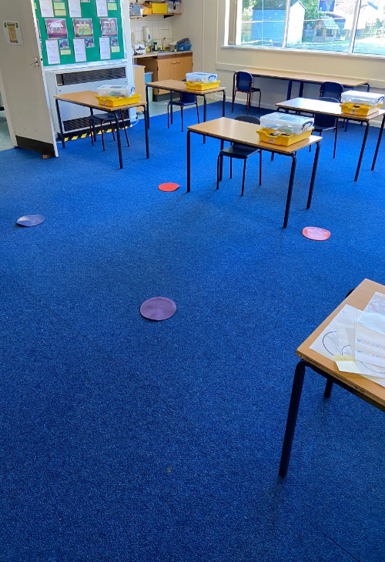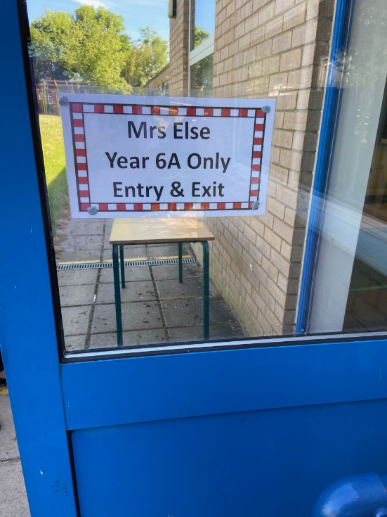

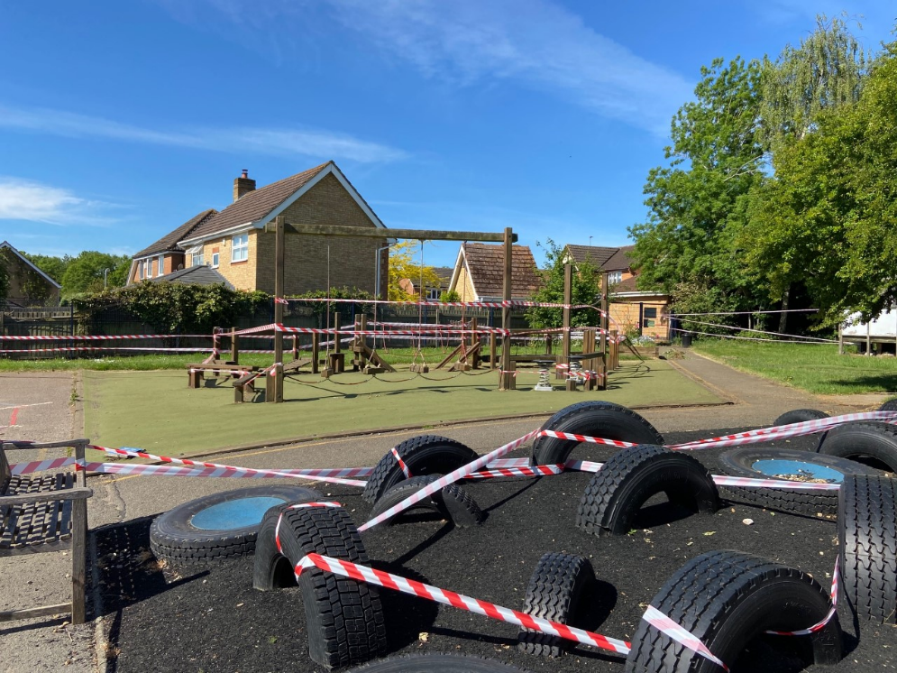

There will be a lot of changes when your child/children return, and the main reason for this note, is to encourage you to discuss these with them. Their school looks drastically different. How they enter the school, play, learn and interact is very different. If they are prepared for this prior to arrival, it will reduce any anxieties they may have. The way that they will remain within their smaller communities, arrive at separate times and have their own dedicated tray of school tools will be unusual for them. Thank you for preparing them for this.
There will always be areas which people can spot and say should be better, and we would really welcome any feedback if you have any experience that you can bring to this, to ensure greater confidence. However, I believe, that all the staff at the school have really created the safest environment possible given the circumstance.
I’d like to thank all the teachers, teaching assistants and support colleagues for all their hard work, dedication and commitment to achieving the safest possible environment. They have been selfless, putting aside their own personal feelings and possible anxieties, to support our community and children.
If anyone should have any questions about the risk assessments please contact me via the school office.

Kind regards,

Matthew Hoddinott

(Health and Safety Governor)

