Thursday 3rd December 2020

Dear Parents/Carers

I hope you are all well. Here at Old Stratford Primary School the children have been working incredibly hard. Catch up interventions are in full swing and have been effective at ensuring the children receive important curriculum content on elements of learning that they had missed during the first lockdown.

Year 2 children will be taking their phonics screening test the week commencing the 7th December. This test would normally be done at the end of Year 1 but due to the COVID lockdown, was postponed by the government until this current term. The children have been working hard on their phonics so this a chance for them to show what they have learnt and retained. Please be reassured that this test is conducted in a very low-key way to ensure that the children do not feel stressed about it in any way. Therefore, it is advisable not to talk to your child about this test as it could cause them to become anxious about it, resulting in them underperforming.

Parent Consultations
The telephone Parent Consultations that took place on the 18th and 19th November proved to be very successful. I would like to thank all parents for keeping to time and allowing the teachers to get to every appointment as close to ‘on time’ as possible.

Christmas
I am aware that many families are starting their preparations for Christmas earlier than ever this year and I thought it would be a good time to explain what Christmas at Old Stratford Primary School is likely to look like under the current guidance and restrictions.

Unfortunately, having been placed into tier 2 by the government and with COVID cases quite high in the local and surrounding area, we will be unable to invite parents into school to experience the traditional Old Stratford Christmas of Nativities and Carol concerts. However, this does not mean that Christmas has been cancelled at Old Stratford Primary School!

Shows and Carol Concerts
We hope to still give all the children an exciting build up to Christmas. Key Stage 1 and EYFS will be performing the Nativity story in their own bubbles and we hope to record these and share them with parents. Our Key Stage 2 children will be learning some traditional Christmas carols and coming together in a COVID safe outdoor Carol service around the Christmas tree in the playground. The children will be performing this on the 14th December and we will send this to you as soon as possible.

Christmas Jumper Day
Normally at this time of year, OSSA would hold a Christmas Jumper Day to raise money for school funds. However, this year OSSA have decided to continue to raise funds in this way but to split the donations with ‘Save the Children’ charity who also hold their Christmas Jumper Day on the 11th December. Therefore, we invite your child to wear a Christmas Jumper on Friday 11th of December with their normal school uniform. Please provide a donation of at least £1, which your child can bring on the day and hand in to their class teacher.

Christmas Roast
Christmas Roast will be served the week commencing the 14th December. If you have not booked your child’s Christmas Roast please do so by the end of Friday the 4th December. Please see below for your child’s allocated Christmas Roast Day:

Monday 14th December – EYFS and Year 1
Tuesday 15th December – Year 2 and Year 4
Wednesday 16th December – Year 3 and Year 5
Thursday 17th December – Year 6

Even though the Christmas Roast will need to be served in the classrooms, a festive atmosphere will still be created with Christmas music and crackers, which have been provided by OSSA.

Christmas Parties
All children are welcome to come dressed in their own party clothes on their Christmas Roast Day as the children will have a visit from Father Christmas as well as enjoy some COVID safe party games prepared by their teacher.

Christmas Cards
Normally at Christmas, we would have a Christmas Post Box in school where the children can post their Christmas cards to children and staff across the school. Unfortunately, this year we will have to restrict this to Christmas cards for children within their own class bubbles.

We would like to say a huge thank you to Camilla & Marco’s parents for their very kind donation of a beautiful Christmas tree to brighten up the playground.

Finally, I would like to thank everybody for their generous donations of Selection Boxes and treats for the local foodbank. A big well done to Ava and Victoria from Year 6 who helped organise and advertise the event and even helped take the donations to the foodbank.

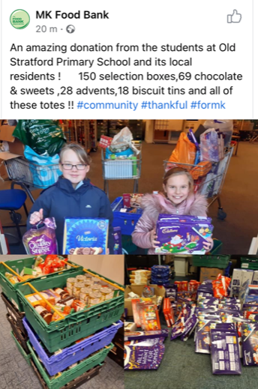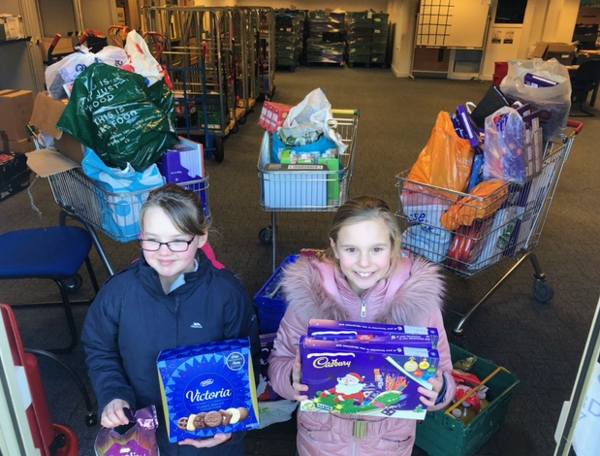

As parent’s are unable to visit the school, I will be posting some highlights of the Christmas period on the Headteacher’s Blog that can be found on the school website or on your Jotter App.

Please be aware that school closes earlier at the end of a term. Below are the pick-up times for each year group for Friday 18th December.

Year Group | Pick up Time | Allocated Gate
EYFS | 2.00 pm | Car Park Gate
Year 1 | 2.10 pm | Car Park Gate
Year 2 | 2.00 pm | Main Gate
Year 3 | 2.00 pm | Back Gate (Dickens Drive)
Year 4 | 2.10 pm | Main Gate
Year 5 | 2.10 pm | Back Gate (Dickens Drive)
Year 6 | 2.20 pm | Back Gate (Dickens

Children will return to school in the New Year on Tuesday 5th January 2021.

Kind regards,

Mrs Sarbutts

