Friday 26th March 2021
Dear Parents/Carers,

It has been wonderful to have a full school again. The children have been fantastic as they have settled back into routines and working hard. I am sure there will be some exhausted children needing a well-earned rest over the Easter holiday.

I would like to thank you all for being really excellent at drop off and pick up times. It feels really slick and well-spaced out. Please continue to stick to the allocated time slots and help us all stay as safe as possible. Please note that school finishes earlier at the end of term.

Year Group | Pick up Time | Allocated Gate
EYFS | 2.20 pm | Car Park Gate
Year 1 | 2.30 pm | Car Park Gate
Year 2 | 2.20 pm | Main Gate
Year 3 | 2.20 pm | Back Gate (Dickens Drive)
Year 4 | 2.30 pm | Main Gate
Year 5 | 2.30 pm | Back Gate (Dickens Drive)
Year 6 | 2.40 pm | Back Gate (Dickens Drive)

Sadly, Mr Beel will be leaving us at the end of term to retire. We wish him well and would like to thank him for all his hard work and support over the years.

Thank you to those parents who filled in the Lateral Flow Testing poll. It was interesting to see that over 50% of our families have taken up the free home testing offer from the Government. This adds an extra layer of protection to all of our school community. With colds and allergies sometimes displaying similar symptoms to COVID, lateral flow testing can quickly eliminate a case of COVID especially if testing is done regularly. However, please note that these tests should not be used instead of a PCR test if you are showing symptoms and do not regularly use the LFT.

If you would like to take advantage of the free Lateral Flow Testing, you can pick up packs of tests from Wolverton Agora in Milton Keynes (MK12) they are available to pick up between the hours of 8am and 1pm. The household testing guidance has also been updated to reflect that individuals can and should order their home testing kits online, whereas previously there was an expectation that households should not order online if they could get a test through other methods. The guidance now states “You can order 1 pack of home test kits containing 7 tests for home delivery. Your tests should arrive within 2 days”.

For those families that are testing, the government advise to continue to test throughout the Easter holiday.

Could I also remind you that the school has a responsibility to continue to track and trace any cases of COVID-19 over the Easter break. Therefore, if a child that has been in school tests positive within 2 days of being at school then you must contact the school by email: office@oldstratford.northants.sch.uk . Please take note of this email as all other emails may not be being monitored during the holidays and your message could be missed. Could I please remind you that teachers emails should not be used by parents now Remote Learning is not taking place. All messages should come through the office email. Teachers are no longer monitoring their email regularly so messages could go unread for some time.

After the Easter holiday, we will slowly start introducing educational enrichment back into our curriculum still adhering to COVID safety at all times.

Therefore, the Life Education will be visiting the school in the first week back after Easter. Below is a timetable indicating what your child’s year group will be learning in these sessions.
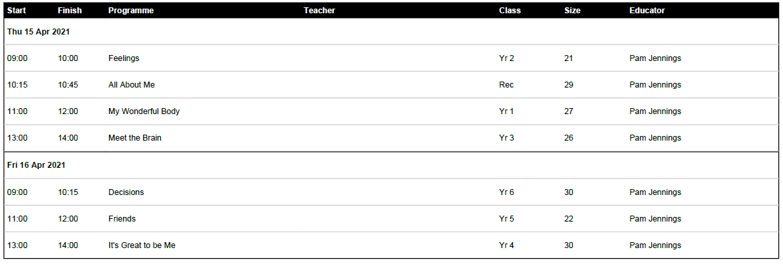

Usually these sessions would take place in a mobile classroom situated in the front car park but due to safety reasons, the sessions will take place in a tented classroom instead. Below is a picture of the tented classroom.
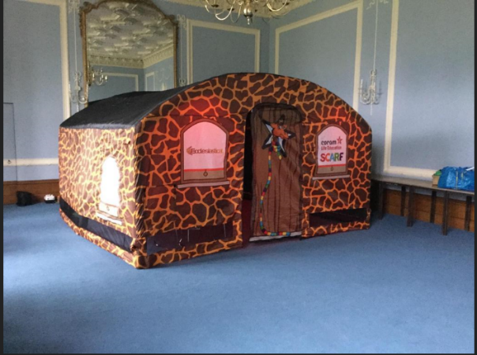

On Thursday 22nd April, Year 4 will begin their Strings Project. This is a fantastic opportunity where the children get to learn how to play the violin. NPAT, who run the sessions, will teach the children on a weekly basis for 10 weeks.

Another date for your diary is Wednesday 21st April when we will have the photographer in to take class photos.

Finally, I would like to wish you all a safe and restful Easter break. I look forward to seeing you all again on Monday 12th April.

Kind regards,

Mrs Sarbutts

