Friday 30th April 2021
Dear Parents/Carers,

It has been lovely to see the children return to school after the Easter break, all eager to see their friends again. It was then even better watching the children enter school over the last week or so with their smart new haircuts just in time for the class photos!

During the first week of term the children were able to experience some Life Education in a special pop up classroom in the hall. I’m not sure what the children were more excited about – entering the pop up classroom or just being able to leave their classrooms and enter another area of the school! This was particularly exciting for our Reception Class who have yet to get the whole school experience.

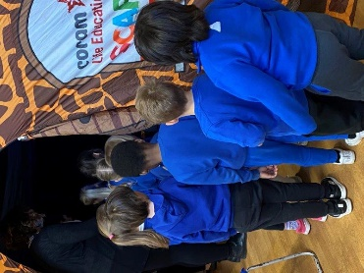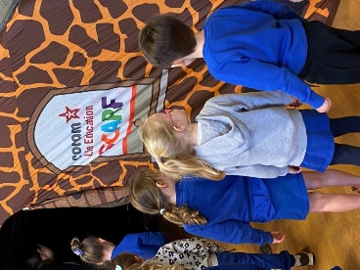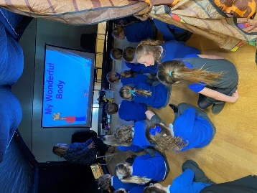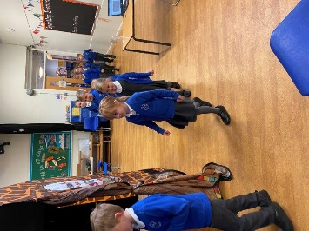
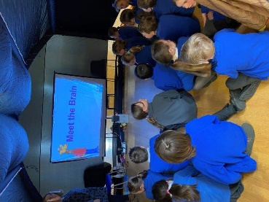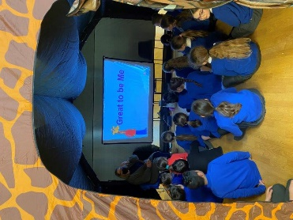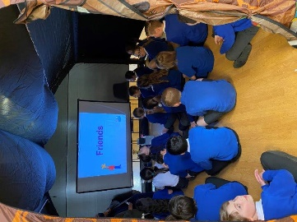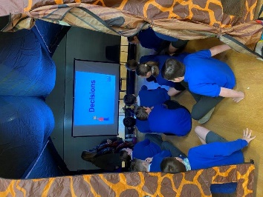

Last week, Year 4 started their Music Project with NPAT music school. They will be learning how to play the violin for the next 10 weeks. This is a great opportunity for the children as they are taught by specialist music teachers.

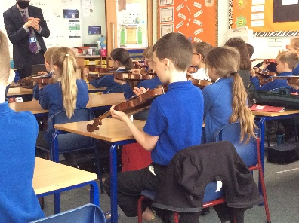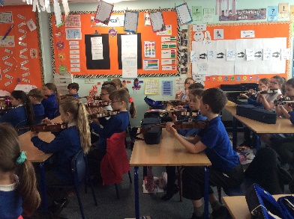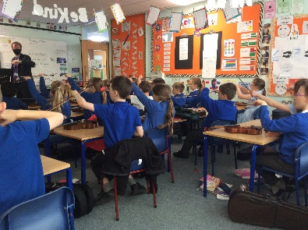

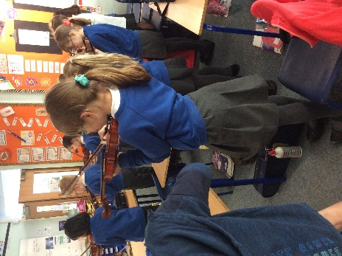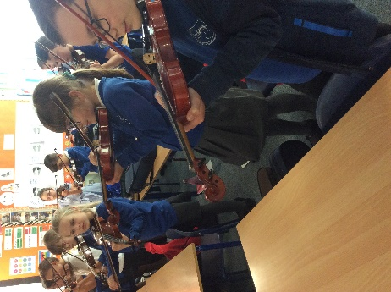

Global Curriculum
You will notice, when you receive your child’s Curriculum Newsletter, a new addition to our curriculum titled ‘Global Curriculum.’ Each year group will now be given the opportunity to practice and apply newly acquired skills in practical ways. We have worked hard to design a curriculum that connects to real life and promotes thinking as a global citizen and develops key skills for our children to make meaningful contributions to society. Through this part of our curriculum we aim to ensure that the children make deep connections between learning and understanding the world that they live in. The children will have an element of ownership of what they learn as they plan alongside their teacher, a meaningful outcome. Although this part of the curriculum is in its infancy we as a school feel it’s an important addition due to the ever changing world that we live in. Look out for more details on your child’s Curriculum Newsletter.

Enrichment Activities
With cases of COVID low in the immediate area and nationally, we are slowly beginning to increase enrichment activities for the children. Enrichment is a valuable part of a child’s school experience and over the past couple of years we have been restricted in what we have been able to access. Therefore I believe that it is important to try and include some of these opportunities over the coming months. All trips and activities will go through rigorous risk assessments and will be compliant with COVID restrictions. Look out for more details from your child’s class teacher over the coming weeks.

Year 6 Transition Days
We have had conformation from Elizabeth Woodville School that their Transition Days for the Year 6 children will be on Tuesday 6th and Wednesday the 7th of July. More details regarding Old Stratford Transition Day for the rest of our children, will follow nearer the time.

Thank you
Mr Andrews has been keen to update the sandpit in the EYFS area all year. After a small plea from the school for wood to help revamp it, Mr Davies (a parent with children at the school) came forward and provided the wood and the labour to totally rebuild the sandpit. We would like to say a huge thank you to him for his time and generosity. We would also like to thank all the parents who donated bags of sand to fill the pit ready for the children to use.

Reminders
We have had a number of children informing the teacher at the end of the day that they are going home with somebody else or a friend in their class. Can I please remind you that if your child is being picked up by somebody else that you inform the office before the end of the day? You will have received by ParentMail a Pupil Premium Application Form, can you please complete and return to the school office so we can make sure that school receives this funding to support our eligible pupils and narrow the attainment gap between them and their peers. Please contact the school office if you have not received your form.

PE
This is a polite reminder regarding PE kit. I am aware that whilst shops were closed it has been difficult to replenish out grown school kit and uniform but now shops are open could I please ask that children are wearing the correct uniform including for PE. Children should not be wearing trainers to school on non PE days.

Kind regards,

Mrs Sarbutts

